<http://apmonitor.com/pdc/index.php/Main/TankBlending>

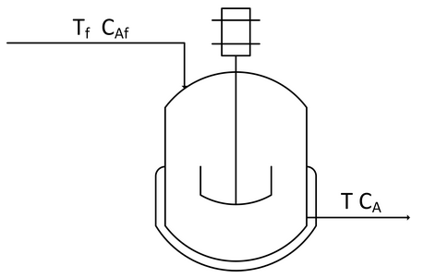

Create a dynamic model of concentration and temperature based on a physics-based derivation from species and energy balance equations. A mixing tank has a liquid inlet stream and outlet stream. The tank is well mixed so the concentration and temperature are assumed to be the same throughout the reactor.

Start with the [species and energy balance equations](http://apmonitor.com/pdc/index.php/Main/PhysicsBasedModels) and derive the dynamic concentration and temperature response. Develop the concentration response and then add the temperature response. Assume a constant volume V of 100 m3 and an inlet flow rate or q of 100 m3/hr.

**Species balance**

$$\frac{dn_{A}}{dt}={\dot{n}}_{A_{in}}-{\dot{n}}_{A_{out}}+{\dot{n}}_{A_{gen}}-{\dot{n}}_{A_{cons}} \\ \frac{dC_{A}V}{dt}=c_{A_{f}}q_{f}-c_{A}q-r_{A}V$$

$$q_{f}=q$$

$$r_{A}=0$$

$$\frac{dC_{A}}{dt}=\frac{q}{V}(c_{A_{f}}-c_{A})$$

**Energy Balance**

$$\frac{dh}{dt}={\dot{m}}_{in}{\hat{h}}_{in}-{\dot{m}}_{out}{\hat{h}}_{out}+Q+W_{s}$$

$$h=mc_{p}(T-T_{ref}) \\ \hat{h}=c_{p}(T-T_{ref}) \\ m=ρV \\ \dot{m}=ρ\dot{V}=ρq \\ q_{f}=q \\ Q=0 \\ W_{s}=0 \\ T_{ref}=0$$

$$\frac{dρVc_{p}T}{dt}={\dot{m}}_{f}c_{p}T_{f}-{\dot{m}}_{out}c_{p}T_{out}$$

$$ρc_{p}V\frac{dT}{dt}=ρqc_{p}T_{f}-ρqc_{p}T_{out}$$

$$\frac{dT}{dt}=\frac{ρqc_{p}T_{f}-ρqc_{p}T_{out}}{ρc_{p}V}$$

$$\frac{dT}{dt}=\frac{q{(T}_{f}-T_{out})}{V}$$